Humanity First 2019--Guatemala

This November, Loyola Department of Ophthalmology opened a new chapter in global service, with a surgical mission to Nasir Hospital of Guatemala. The newly built, state of the art Nasir Hospital provides year-round care from local providers in a wide range of specialties while serving as host site for surgical missions for Loyola volunteers.

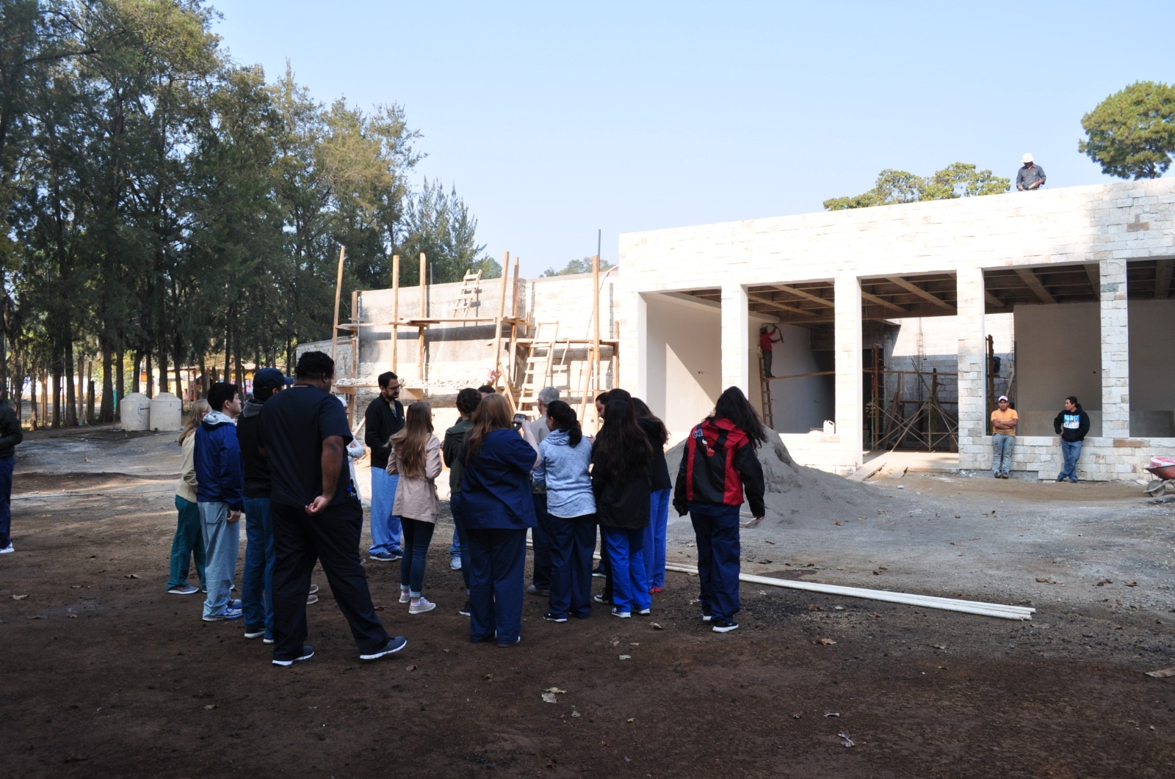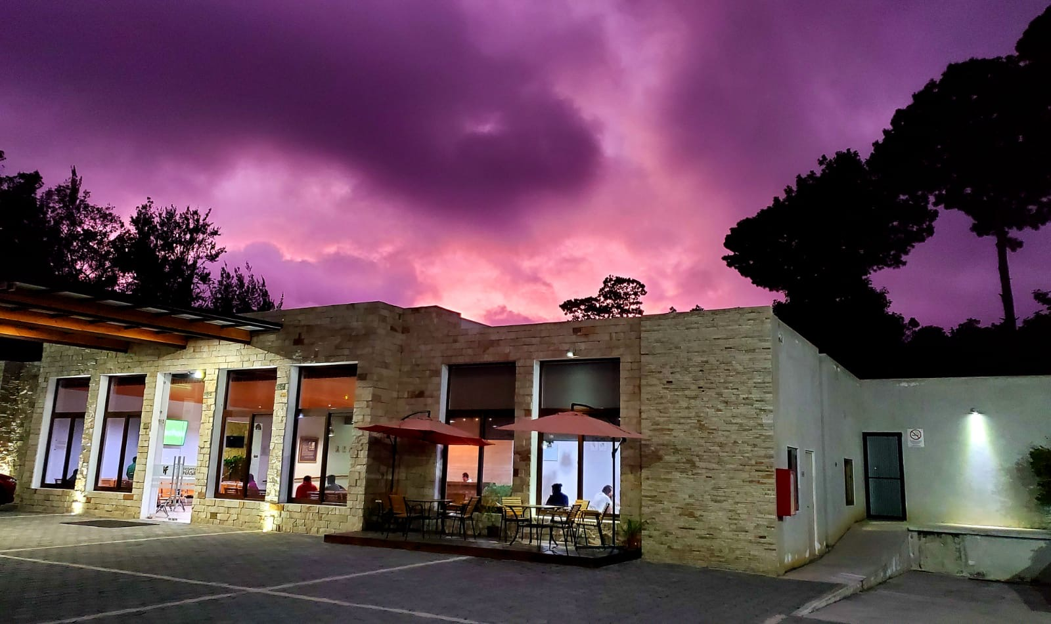

Photo 1: Nasir Hospital March 2018. Photo 2: Sunset at Nasir Hospital November 2019

Since 2012, volunteers from Loyola have partnered with Humanity First to provide week-long eye camps. This year, Dr. Charles Bouchard, senior resident Dr. Michael Henry, and ophthalmic technician Yolanda Buick joined a team of volunteers from the U.S. and Canada to serve well over 100 patients from remote areas of Guatemala.

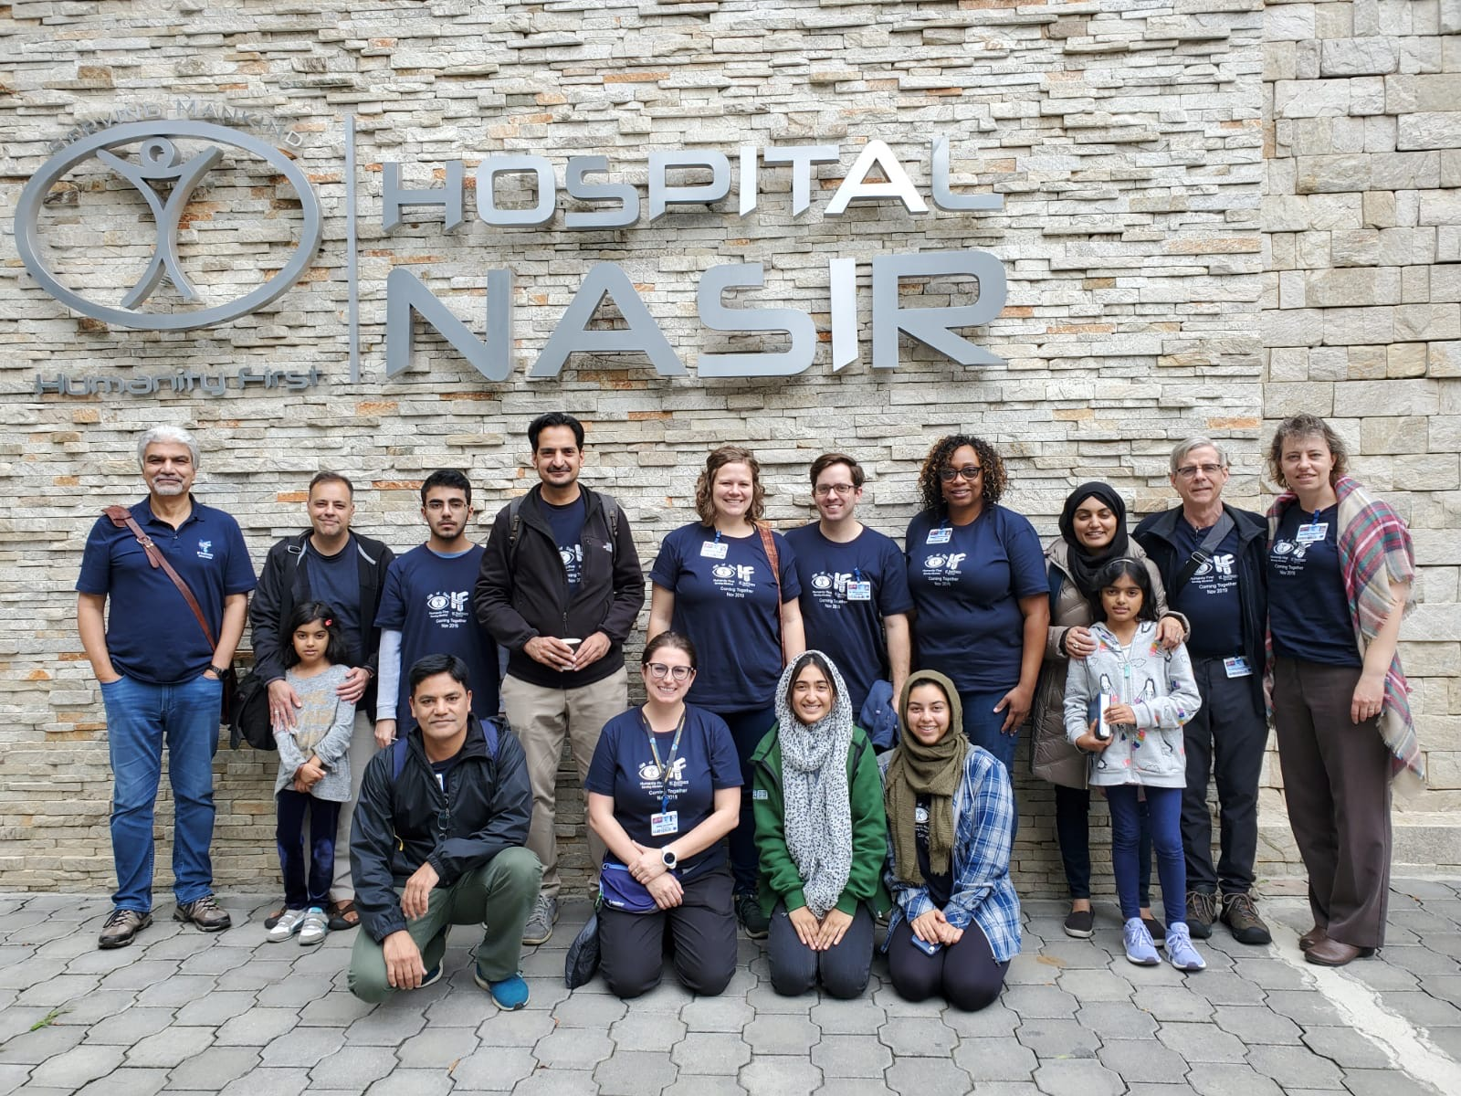
Photo 3: Team of volunteers at Nasir Hospital.

These patients would otherwise be unable to have eye surgery despite significant disability from various eye conditions.

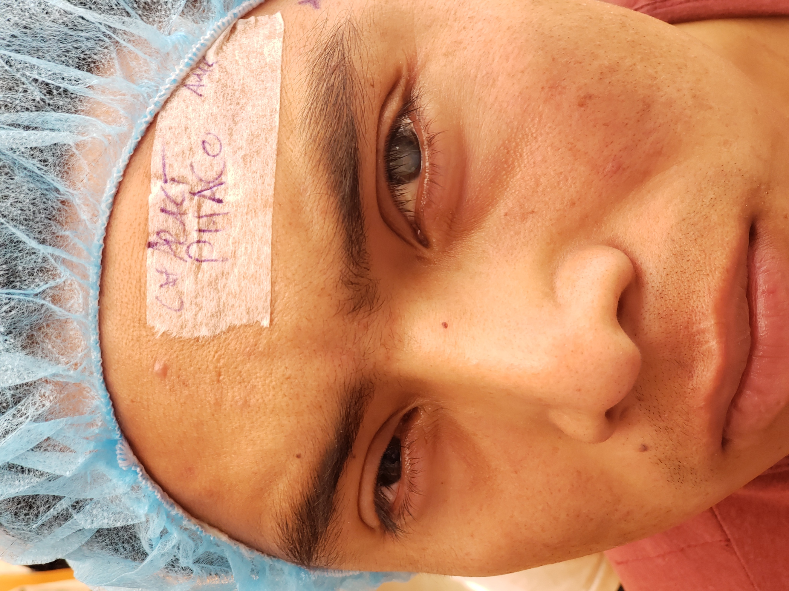
Photo 4: Dense white cataract in young Guatemalan patient. Vision improved from light perception to 20/30 on post-operative day 1. (Photo taken with patient permission)

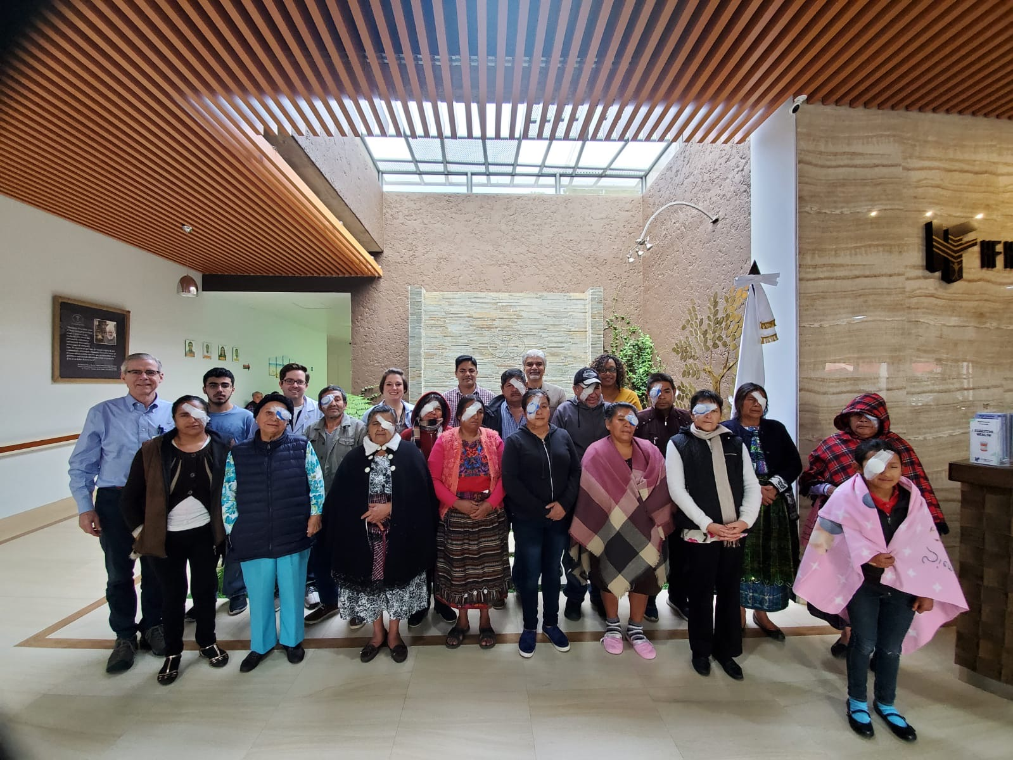

Photo 5: Group of post-operative patients on last day of surgical camp. (Photo taken with patient permission)

Dr. Bouchard worked around the clock performing ocular surface surgery as well as meeting with local officials to discuss ways to improve access to high quality, cost-effective and sustainable eye care.

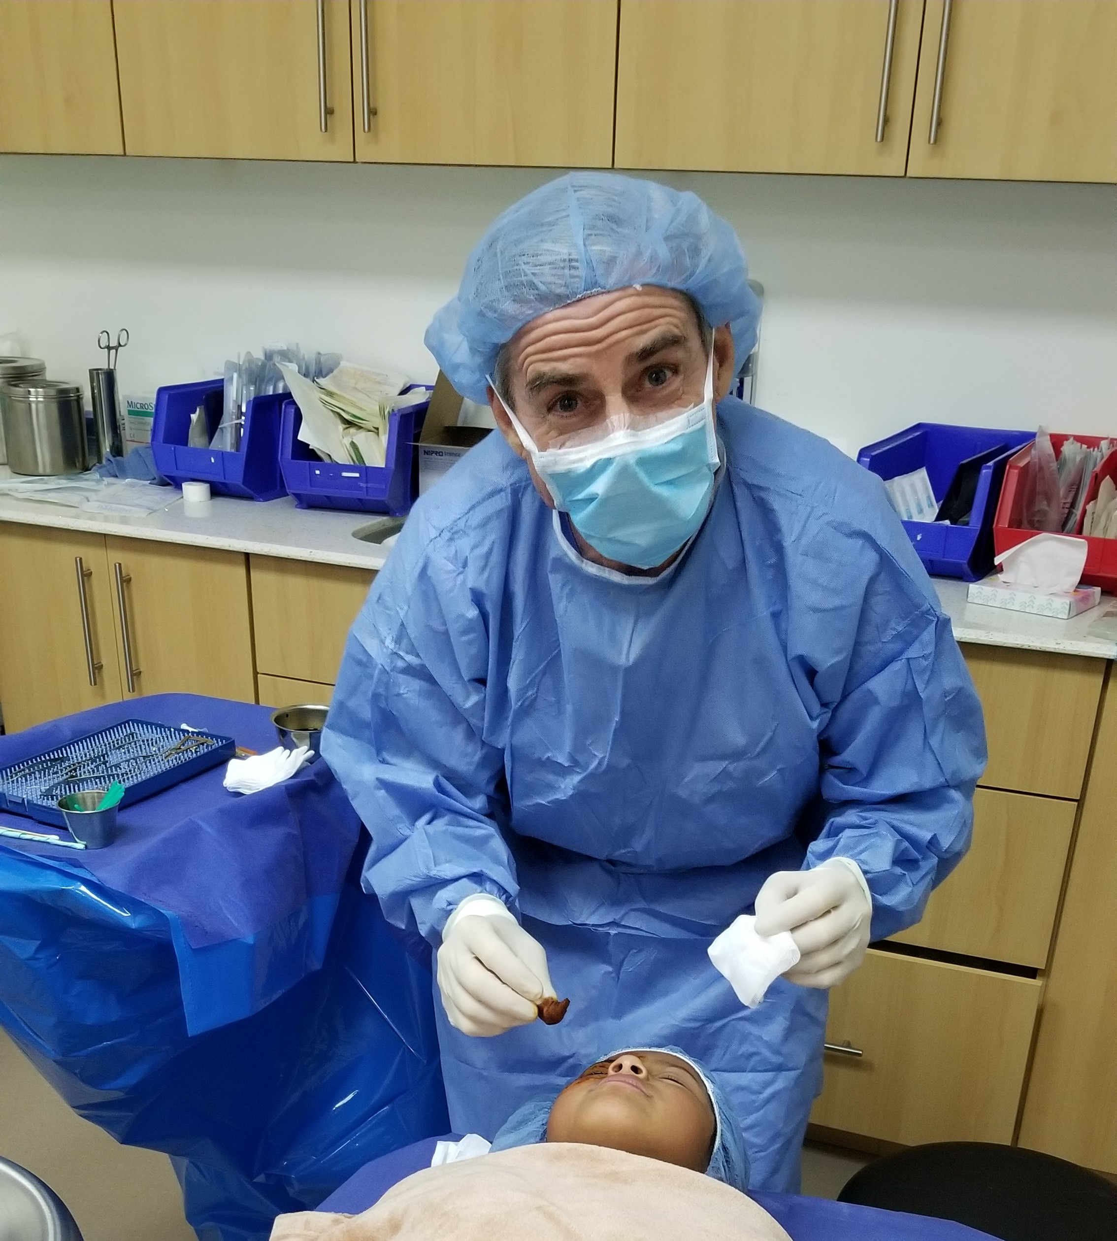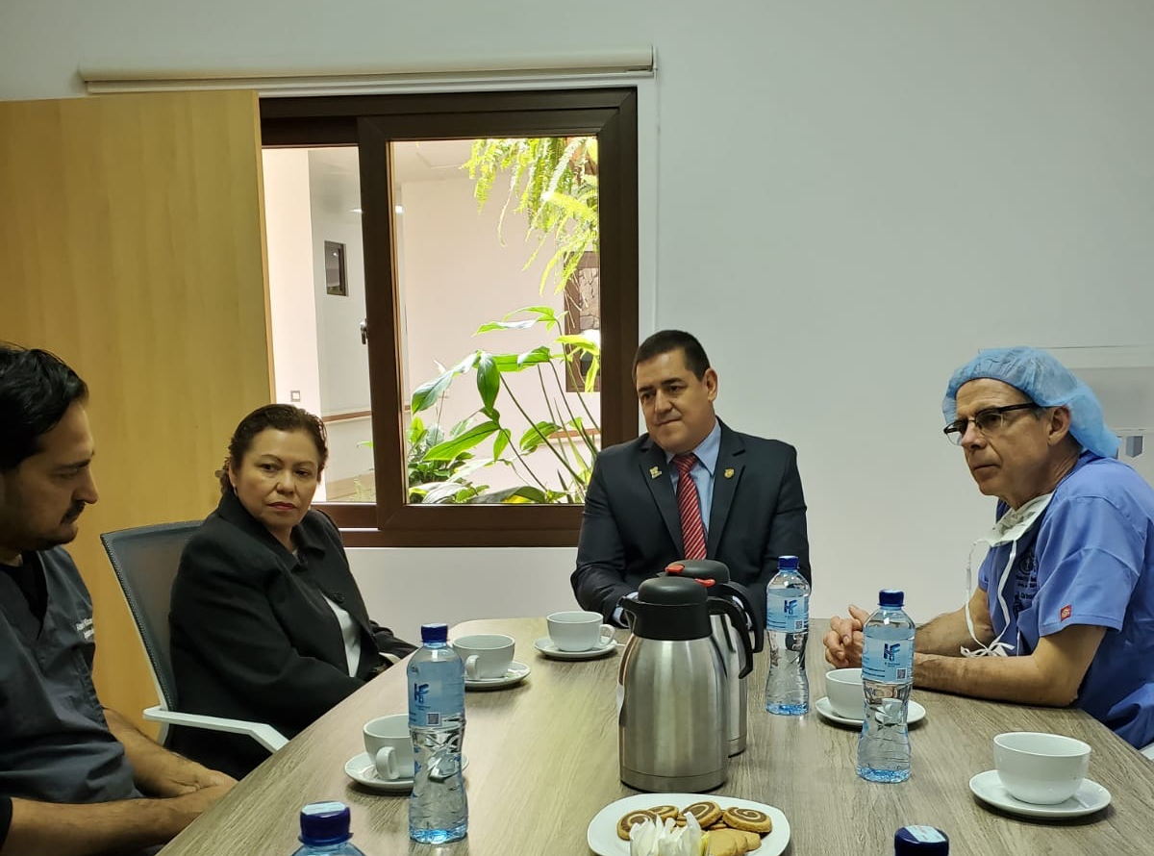
Photo 6: Dr. Bouchard preparing for surgery Photo 7: Dr. Bouchard meeting with the Minister of Health.

Senior resident, Dr. Michael Henry worked alongside Loyola Ophthalmology alumnus, Dr. Ahsan Khan as well as Dr. Karen Small and Dr. Tayyeba Ali removing dense white cataracts.

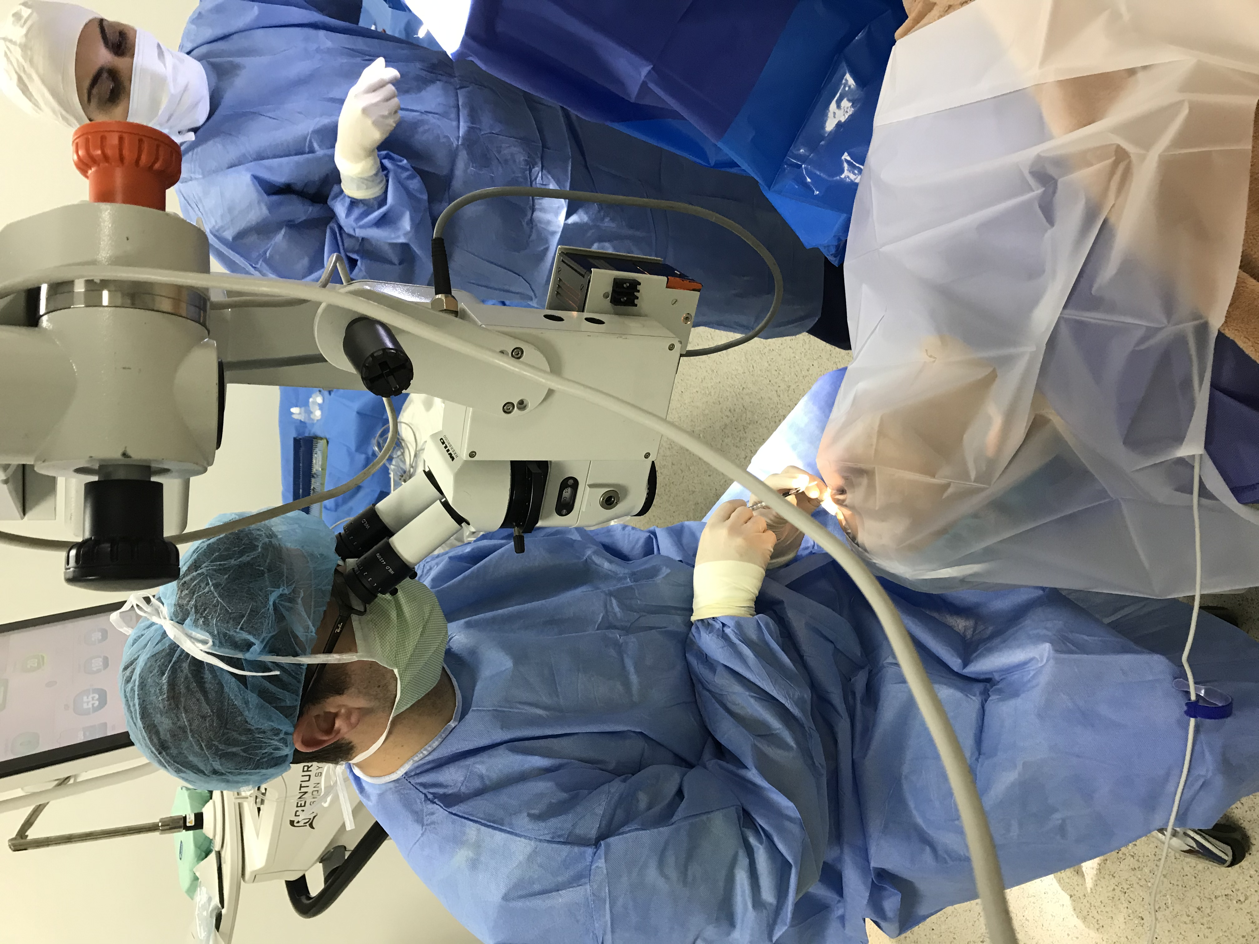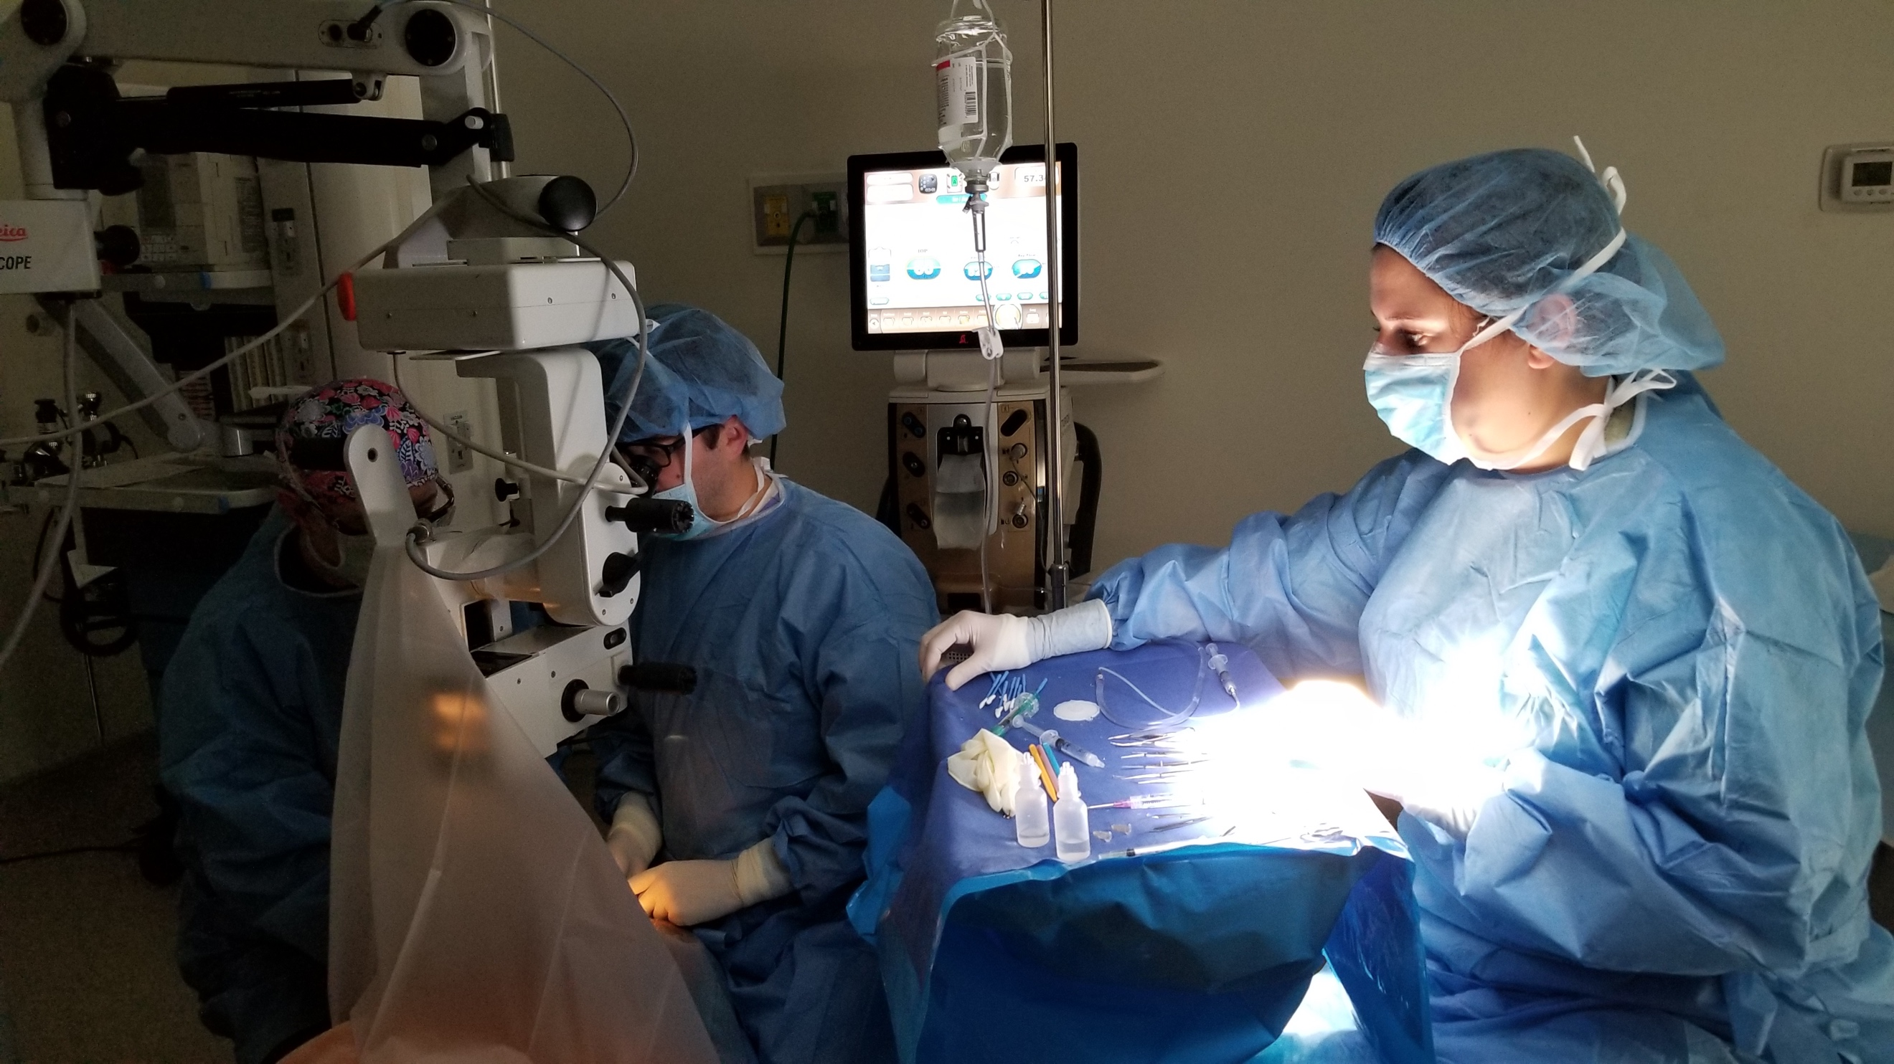

Photos 8 and 9 : Dr. Michael Henry performing phacoemulsification and small incision extracapsular surgery.

Yolanda Buick donated her time and skills as an ophthalmic technician to help perform A-scans, manual keratometry, and assist in all areas of the clinic.
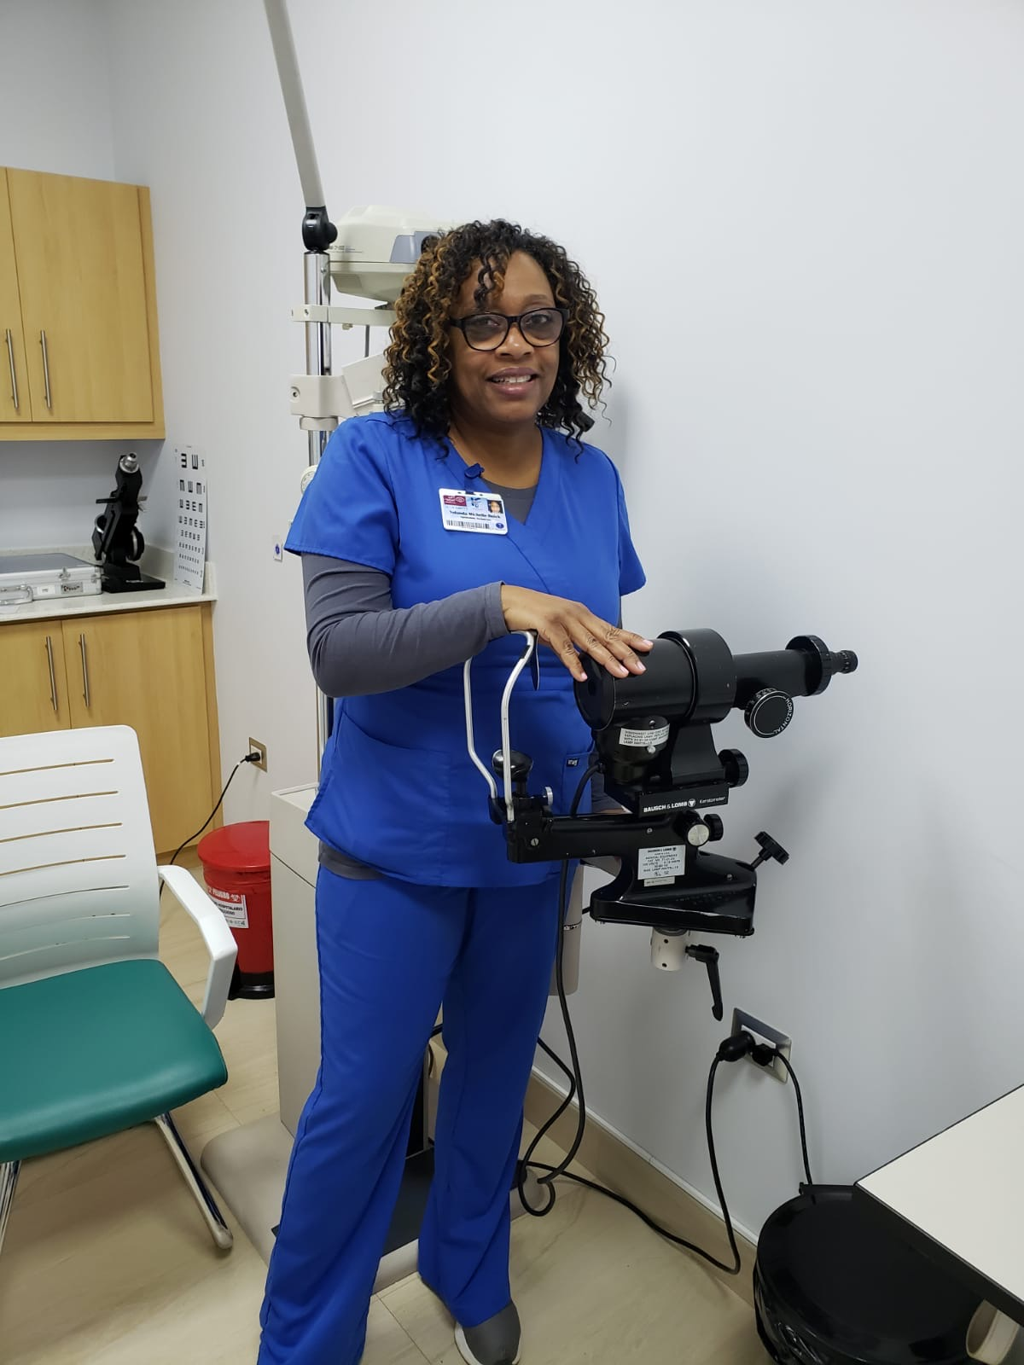

Photo 10: Yolanda Buick performing pre-operative lens calculations.

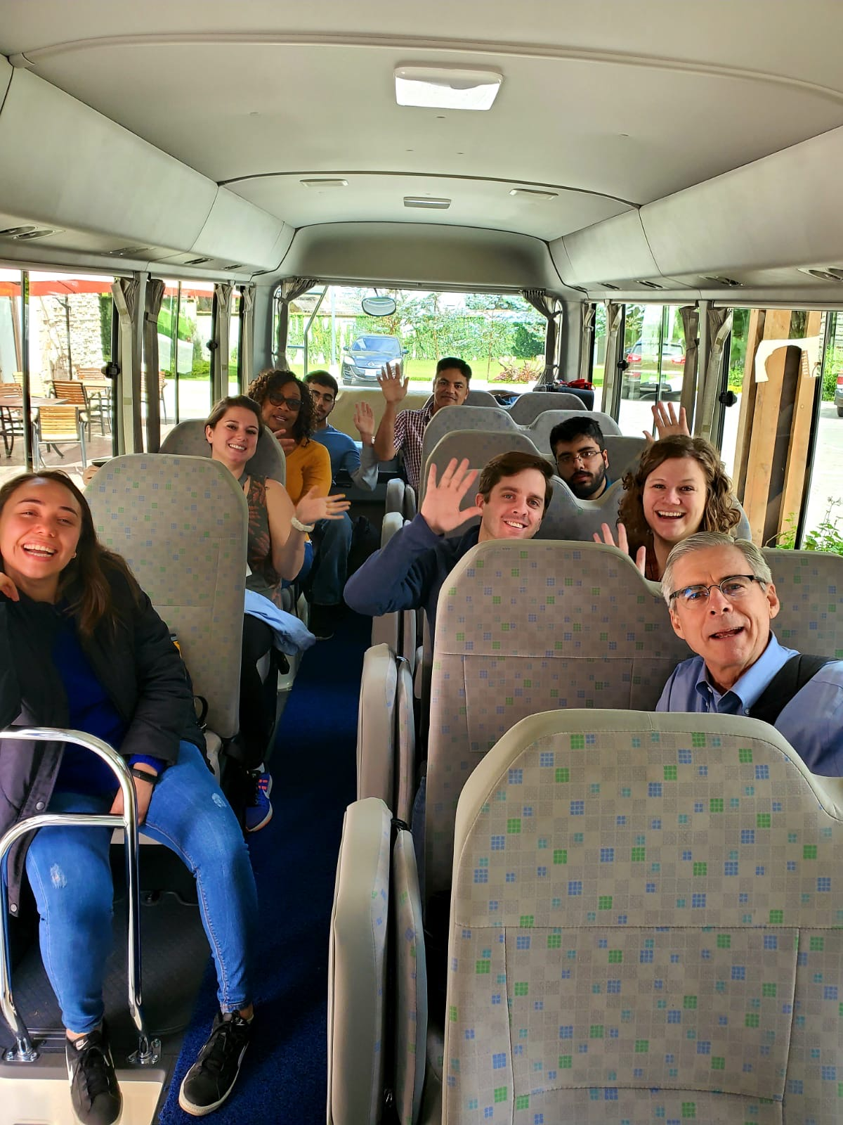

Photo 11: Team members waving good-bye on last day.

Of course, none of this trip would have been possible without the logistical support of Senior Secretary Alycia Snow.

Loyola Ophthalmology has a long history of service to the local and international community. The surgical mission achieved its goal of providing immediate care to many in need as well as promoting sustainable solutions to health disparities through education and partnership with local surgeons.

Visit https://hfgiftofsight.tumblr.com/ for more photos.

Interested in assisting with future surgical missions? Contact Alycia Snow at alycia.snow@luhs.org.

